**A Brief Report of Millet Awareness Rath for Celebration of National Nutrition Month.**

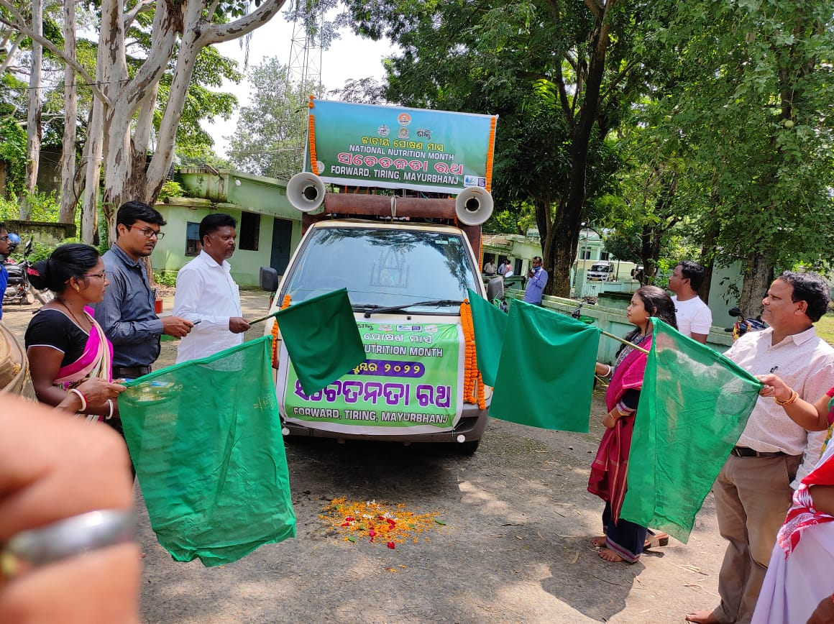

**Tiring, Dt.23.09.2022** Today On the celebration of National Nutrition Month a Millet Awareness Rath has started from Tiring Block, Mayurbhanj District. Organized by Farmers Organization For Research Welfare and Rural Development (**FORWARD**) with support of Odisha Millet Mission. On Friday the Awareness Rath has Inaugurated by Block chairman Mr. Parameswar Samadh, BDO Basanti Lakra, BAO Jayakrushna Nayak, CDPO Mrs. Krushna Kumari Jena by shoaling flags. On this occasion Block coordinator of FORWARD organization Mr. Pintu Samantaray, Livelihood coordinator Mr. Madan Marandi and all CRPs Mrs. Chhita Murmu, Mr. Meghray Murmu, Pradeep Nag, Mr. Rajesh Sahaya, Mr. Panchanan Murmu also present. The aim of Awareness Rath was to understand people to cultivate Ragi, Finger Millet and to prepare that related food in their daily food habit and also to get benefit with this cultivation. This Rath of sentient will migrate various villages in Tiring Block for consecutive eight days.

After that Awareness Campaign Started From Ranisahi Village in Tiring GP and every day the Nutrition Rath Travelled from date 23/9/2022 to date 30/9/2022 to each village of 10 GP under Tiring Block. In that Responsible had taken by Block Coordinator, Additional Block Coordinator and All CRP discuss with the Farmers about ODISHA MILLET MISSION.

Such as: Change in Claimant.

Effects of Chemical fertilizer .

Process of Millet cultivation.

Govt. facilities.

Health benefits.

So that, they had understood and gave opinions positively with interested for Millet cultivation in Rabi Session and Next Year.

We are very happy that as per your instructions we have visit to every village and successful thought the farmers about Millet cultivation,